Use Cases and Logical Architecture

* XID: X00161872
* Name: Elijel De La Cruz
* Project Title: Busimple

**Provide at least 6 Use-cases describing the functionality of the proposed system**

## Section 1: For Each Use Case:

|  |  |
| --- | --- |
| Title (goal) | Create an Account |
| Primary Actor | Unregistered Users |
| Story | User will click on register on the navbar, be redirected to a sign up page prompting to add the required details, afterwards will be then redirected and logged in. |

|  |  |
| --- | --- |
| Title (goal) | Sign in |
| Primary Actor | Registered Users |
| Story | User will click on login on the navbar, be redirected to a log in page prompting to add their username and password, once provided their correct details, they will then be redirected onto the homepage with their account signed in. |

|  |  |
| --- | --- |
| Title (goal) | Search Routes |
| Primary Actor | Unregistered/Registered |
| Story | Users will be able to click onto the route section of app and be able to enter a route they desire, and it will show the search of the route and they are then able to click onto it and view it |

|  |  |
| --- | --- |
| Title (goal) | Nearby Stops |
| Primary Actor | Registered / Unregistered Users |
| Story | Users will be able to view their nearby stops in their location once they allow their location to be tracked, and it will show the stops around the area and they are able to click onto the stop and further view the details and stop times of the stop |

|  |  |
| --- | --- |
| Title (goal) | Destination Search |
| Primary Actor | Registered / Unregistered Users |
| Story | This will allow the user to search for the routes going to their desired destination, if they search e.g Rathmines, it will showcase all routes going to go past Rathmines. |

|  |  |
| --- | --- |
| Title (goal) | Favourite Stops |
| Primary Actor | Registered |
| Story | Users that go onto a stop times page will have an option to favorite the stop, and once they do it will add it to their favorites list. The user is then able to access their favorites list and easily navigate to their favorites stop and view the stop times for it. |

## Section 2: Logical Architecture

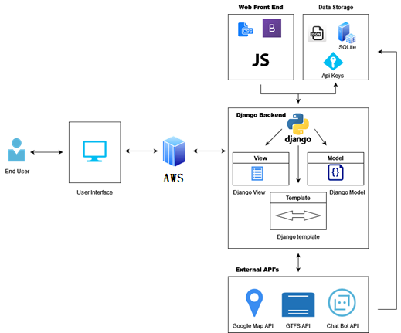

**Discuss each component of your architecture**

AWS EC2 will be used to host the Django Website. Django will be used for the backend, creating the views, models, and templates for the project. The External Api’s, google maps, gtfs-r, chat-bot will be used for the project, google maps displaying the location of stops, gtfs-r to display bus information, and chat bot for FAQ. Data will be stored in a MySQL Database and Json files. The Front end of the project will use HTML, Bootstrap, and JavaScript for the user interface and design.

**Add numbers to the arrows and discuss the flow of data**

1(User) will go onto 2(UI) which is hosted on 3(AWS) and will POST/REQUEST from 4(DjangoBackend) to get the data needed. 4(DjangoBackend) will grab information from 5(external apis) and then will be saved onto 6(data storage) which 4(DjangoBackend) will be using to get the API information. 7(front end) will then display the interface of 4(DjangoBackend) to the 1(User).